NATIONAL UNIVERSITY OF SINGAPORE
Department of Electrical and Computer Engineering
AY 2022-23
EE4502 Project-Based Lab Experiments

Exp 1: AC (Induction Motor) Drive System

Main objective:
The main objective of this part of the experiment is to study AC variable speed drive (VSD) system. The AC VSD drive system consists of a three-phase bridge rectifier (AC-DC) at the front end, inverter (DC-AC) at the back-end and AC motor (asynchronous/induction). In the diode bridge rectifier stage, fixed voltage and fixed frequency three-phase AC power source is rectified into unregulated DC power. Through the PWM inverter, the unregulated DC power is converted back into variable voltage and variable frequency regulated three-phase AC power source to drive the AC induction motor. The AC Drive system controls speed and torque of the AC motor by adjusting the voltage and frequency supplied to the motor in a coordinated way. There are two different types of control modes discussed in the experiment namely open-loop and closed-loop v/f control of the induction motor. For each mode, the dynamic and steady-state performances of the drive system are investigated.

Discussions

Discussion 1: Introduction to DC-to-AC Conversion using pulse width modulation (PWM) inverter

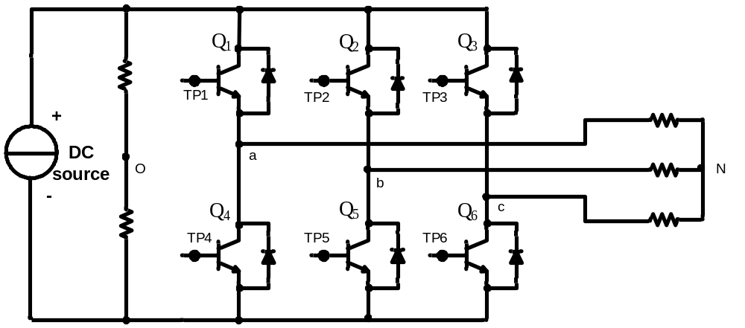
Figure.1: Circuit diagram of PWM inverter

Three phase PWM inverter can be used to obtain a high-power controllable AC voltage and frequency with high efficiency from a DC voltage by controlling the IGBT semiconductor switches (Q1 to Q6) ON and OFF operations. The circuit diagram of a three phase PWM inverter is shown as Figure.1.

Figure. 2 gives the idea of how to generate the AC voltage source by controlling the IGBTs operation. In Figure.2, the IGBTs act as switches which close and open in turn. The output voltage (Vo) equals +V_{dc}/2 when Q₁ is closed and Q₄ is opened and the output voltage is –V_{dc}/2 when Q₁ is open and Q₄ is closed, as shown in Figure.2.
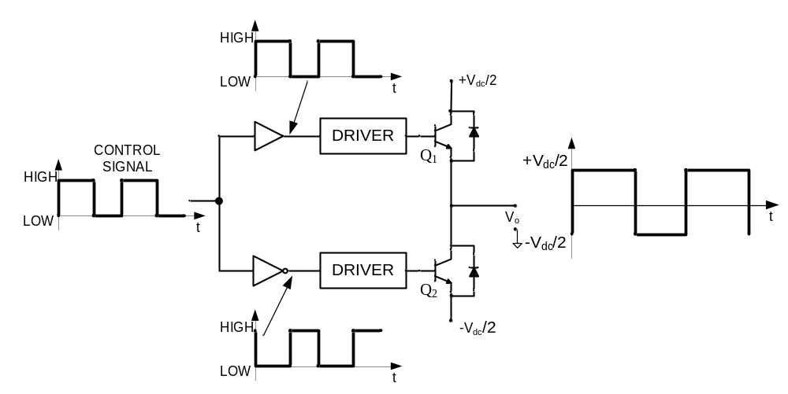
DC voltage
AC voltage
Figure.2: AC voltage source generation

However, the waveform of the output voltage is not sinusoidal; rather it is a rectangular wave whose amplitude varies from +Vdc/2 to –Vdc/2 and whose pulse width varies in accordance with the signals which control the switching of the IGBTs. By filtering and modulating the duration of these pulses at the output of an inverter, it is possible to obtain an output waveform that is close to sinusoidal shape. The modulation of the pulse duration is called pulse-width-modulation (PWM). It is therefore possible to obtain a sinusoidal waveform by sinusoidally varying the duty cycle of the IGBT control signals. The frequency of the control signal is the same as the output AC voltage frequency, and the frequency at which the duty cycle varies, is called the carrier frequency.

Discussion 2: Introduction to v/f Control of Squirrel-Cage Induction Motor

A three-phase squirrel-cage induction motor can be represented by three transformers whose primaries correspond to the three phase stator windings, and whose secondary windings correspond to the three phase rotor windings. It is thus possible to determine the behavior of a motor by using a circuit similar to that of the transformer shown in Figure 3.
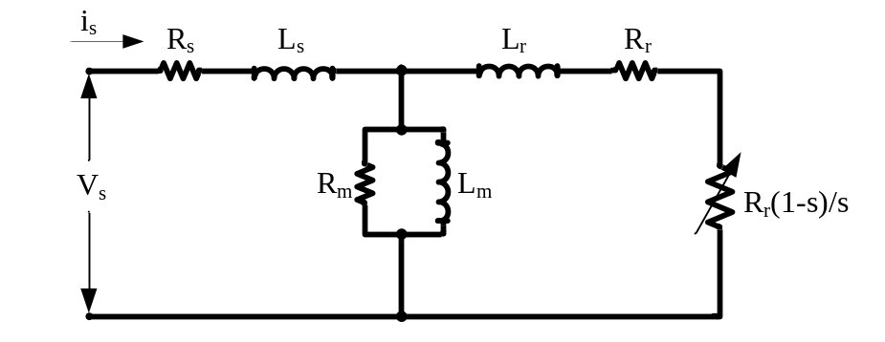
Figure.3: Per-phase equivalent circuit of a squirrel-cage induction motor

The circuit shown in Figure.3 allows accurate prediction of the behavior of a squirrel-cage motor for various operating conditions. Stator resistance, R_{s} corresponds to the resistance of the stator winding, and leakage-inductance, L_{s} corresponds to the leakage inductance produced by the flux flowing in the stator winding but which does not flow in the rotor winding. Magnetizing inductance, L_{m} corresponds to the inductance produced by the flux flowing in the stator winding as well as in the rotor winding. The core resistance, R_{m} corresponds to iron/core losses component and its value depends on the source frequency. The rotor resistance, R_{r} corresponds to the resistance of the rotor winding, and leakage-inductance, L_{r} corresponds to the leakage inductance produced by the flux flowing in the rotor winding but which does not flow in the stator winding.

The other resistance shown in the circuit is a variable rotor resistance, R_{r}(1-s)/s. It represents the mechanical load applied to the rotor and depends on the slip of the motor. The equivalent circuit of the motor is thus similar to that of a transformer to which a resistance is added at the secondary to represent the mechanical power delivered by the rotor. Once the circuit equations are solved, the power dissipated by resistor R_{r}(1-s)/s is determined and the power dissipated across this variable rotor resistance indicates the electrical power converted into mechanical power. Because the mechanical power is the product of the torque and speed, it is possible to determine the torque value for each speed of rotation. When the rotor speed equals the synchronous speed (s = 0), the value of resistor R_{r}(1-s)/s is infinite. The current flowing in the resistance is null and no power is delivered to the mechanical load. When the rotor speed becomes lower than the synchronous speed, the resistance value of R_{r} decreases, and current flows through the resistor. The power dissipated by the resistor corresponds to the torque produced by the motor.

In order to build a powerful motor which is able to develop high torque, the strength of the magnetic field of the stator has to be increased. In the meantime, the magnetic flux cannot be increased too much so that the iron begins to saturate. Therefore, the operating point of magnetic flux should be kept at optimal point i.e. at the knee point of the magnetic saturation curve. The magnetic flux depends on the current flowing through the magnetizing inductance, L_{m}. To maintain the magnetic flux constant, the current flowing in the inductance, L_{m} must be kept constant. Since the inductive reactance (X_{m}) will vary in the same proportion as the frequency, the input voltage must be changed according to the frequency change to maintain constant magnetizing current and therefore, magnetic flux in the inductance. In other words, in order to keep the magnetic flux constant, the v/f ratio has to be maintained constant.

Simulations:

Simulation 1: Introduction to DC-to-AC Conversion using pulse width modulation (PWM) inverter

Use the “PWMinverter_a.slx” file for executing the Simulink program. In this exercise, you would study how the three phase PWM inverter works.

1. Run the program with a carrier frequency of 500 Hz (it is rather low due to the educational set-up that we have in the lab., otherwise it should be of the order of 20 kHzs or so) and reference waveform amplitude 0.8 and 50Hz frequency. Set the resistance to be 600 ohms. Observe how to generate the control signals for each switch and the relationship between the switching signal and line voltage V_{ao}, V_{ab} from the scope. You can magnify the waveforms and try to understand the operating principles of the three-phase sine PWM inverter.

Use the Matlab file ‘PWMplot.m’ to understand the working principles of PWM scheme. Use the Matlab file ‘inverterplot.m’ to observe the line voltages V_{ao} and V_{ab}. Use the ‘powergui’ block in the Matlab simulation model to check FFT of the current for phase-a.

2. Only change the frequency in the block of carrier waveform to 2 kHz and observe the difference in the switching signals, and the line voltage V_{ao}, and V_{ab} in the scope and comment accordingly in the report.

Use the Matlab file ‘PWMplot.m’ to understand the working principles of PWM modulation. Use the Matlab file ‘inverterplot.m’ to observe the phase and line voltages V_{ao} and V_{ab}. Use the ‘powergui’ block in the Matlab simulation model to check FFT of the current for phase-a.

Use the “PWMinverter_b.slx” file for executing the Simulink program.

3. Now place inductors (e.g. 1.6 H) in series with the resistive load for each phase. Then observe and discuss the voltage and current waveforms across the resistance.

Use the ‘powergui’ block in the Matlab simulation model to check FFT of the current signal in phase-a. Use the Matlab file ‘inverterplot.m’ to observe the voltage and current across the resistance.

Use the “PWMinverter_c.slx” file for executing the Simulink program.

4. Change the amplitude of the reference signals for phase a, b, c to 0.5, and the frequency of the reference signals to 100 Hz. Observe and explain the voltage and current waveforms across the load.

Use the ‘powergui’ block in the Matlab simulation model to check FFT of the current signal in phase-a. Use the Matlab file ‘inverterplot.m’ to observe the voltage and current across the resistance.

Simulation 2: Introduction to v/f control of induction motor

Use the “acmotor_vf.mdl” file for executing the Simulink program. In this exercise, you would study the forward motoring and forward braking of an ac induction motor. Subsequently, the performance of the v/f control for ac motor drive system under step-change in reference speed or step-change in load-torque command would be examined.

- Set the speed reference to the values of 300, 900, 1500 rpm respectively. For each setting, record the data of the frequency and amplitude of the motor input voltage, the value of the field flux and the speed at steady state. Plot the graph of the ‘v – f’ plot and explain how v/f control scheme works.

Use the Matlab file ‘vfplot.m’ in the Matlab window to observe the performance of the v/f control of the motor.

- Investigate the performance of the drive system when the reference speed is step-changed from 1500 rpm to 1200 rpm at t = 2 sec and from 1200 rpm to 900 rpm at t = 3 sec. Please note that no external mechanical load is applied.

Use the Matlab file ‘wTplot.m’ in the Matlab window to observe the motor drive system response to the speed step-change and identify the forward motoring and forward braking operation.

- Investigate the performance of the drive system when the load torque is step-changed from 0 to 5 N.m at t = 2 sec. Please note that the reference speed is kept constant at 1000 rpm.

Use the Matlab file ‘wTplot.m’ in the Matlab window to observe the motor drive system response to the speed step-change and identify the forward motoring and forward braking operations.

Experiments:

  - Experiment 1: Introduction to DC-to-AC conversion using pulse width modulation (PWM) inverter
  - Experiment 2: Introduction to v/f control of squirrel-cage induction motor

- Equipment

  - Power Supply (8821-2A)
  - Prime Mover/Dynamometer (8960-15)
  - Four-Pole Squirrel-Cage Induction Motor (8221-0A)
  - Vector-Control Drive Converter (9013-1A)
  - Resistive Load (8311-0A)
  - Smoothing Inductor (8325-15)
  - Current/Voltage Isolator (9056-15) – 2 sets
with ±15V/+5V Power Supply (8840-0A)
  - AC Voltmeter - (8426-05)
  - 4-Channel Oscilloscope

CAUTION!

High voltages are present in this laboratory exercise! Do not make or modify any banana jack connections with the power on unless otherwise specified.

Experiment 1: Introduction to DC-to-AC conversion using pulse width modulation (PWM) inverter

1-A Torque versus Speed Graph of the Squirrel-Cage Induction Motor

- Set up the circuit as shown in Figure 4.

- Verify the circuit connection with lab assistants before turning on Power Supply. Switch on the Power supply, set the 24 V-AC power switch to the marked I (on) position.

- Set the Prime Mover/Dynamometer controls as follows:
– MODE switch: DYN.
– LOAD CONTROL MODE switch: MAN.
– MANUAL LOAD CONTROL knob: MIN. (fully CCW)
– DISPLAY switch: SPEED (rpm)

- Set the Oscilloscope as follows:
– Ch1: 1V/DIV
– Ch3: 5V/DIV
– Time: 20s/DIV
– DISPLAY: X-Y
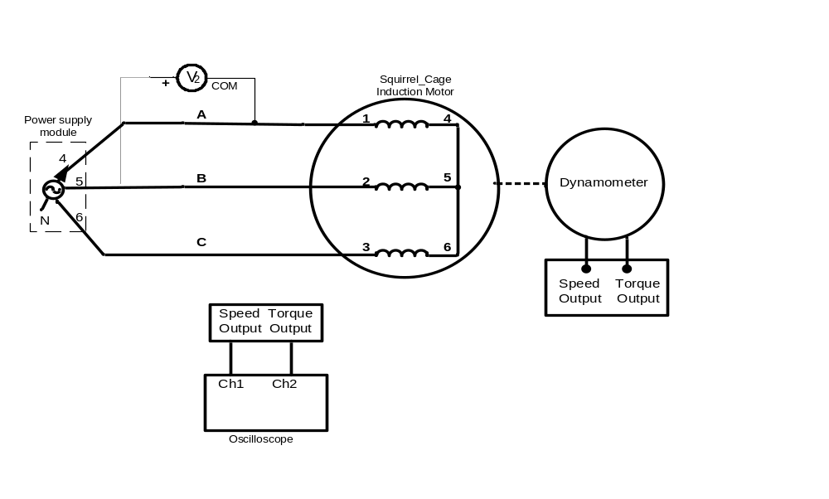
Figure.4: Circuit used to determine the torque versus speed characteristics

- Turn on the Power Supply by setting its main power switch to the marked I (on) position and set voltage control knob to reach the motor rated speed.

- On the Dynamometer, adjust the DISPLAY switch so that the torque indicated on the Dynamometer display. Use the MANUAL LOAD CONTROL knob to increase the load torque by increments of approximately 0.3N.m starting from 0 to MAX. For each torque setting, wait a few seconds for the motor speed to stabilize, and then record the motor speed. Try to capture the graph of the speed versus torque characteristics on the oscilloscope.

- When all data has been recorded, set the MANUAL LOAD CONTROL knob on the Prime Mover/Dynamometer to the MIN. position, and set the main switch on the power supply to the marked O (off) position.
Take note
Q1: In your report, plot the graph of motor torque versus motor speed by using the measured data. Compare the curve of the torque (T) as a function of the speed (n) plotted to the theoretical result.

Experiment 2: Introduction to v/f Control of Squirrel-Cage Induction Motor

2-A Open Loop v/f Control of the Squirrel-Cage Induction Motor

- Use the vector control drive converter module and connect the Four-Pole Squirrel-Cage Induction Motor. Set up the circuit shown in Figure.5.

- Verify the circuit connection with lab assistants before turning on Power Supply. Switch on the Power supply, set the 24V-AC power switch to the marked I (on) position.
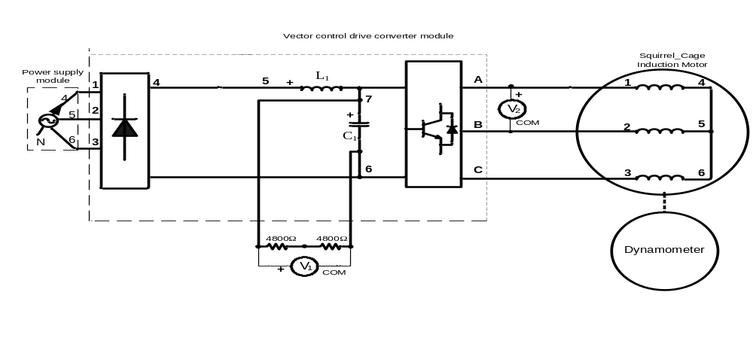
Figure.5: Connection diagram for the ac drive of a squirrel-cage induction motor operating in open loop

- On the computer, start the Drive Wizard application (use admin login (only Mr. Chandra’s)). Turn on the Power Supply by setting its main power switch to the marked I (on) position and set voltage control knob at 100%.

- Click the Connect to inverter button in the toolbar of the Drive Wizard window. The Manual Connection dialog box should appear with “F7” or “G5” or “G7” according to the experiment setup you use.

- Choose the File menu of the Drive Wizard window. This opens the Open dialog box. Select file OPEN.PARMS in the dialog box and Click the Load button to load the file in the computer memory. Click the Inverter Write all parameter values button in the toolbar of the Drive Wizard window. The Download Options dialog box should appear. Click the OK button to close this dialog box.
- Press the Enable button to connect the computer and the Vector-Control Drive Converter. Set the reference speed at 5 Hz and press button to give the gate switch signals of the Inverter.

- This file will run the motor at 20Hz as the reference speed.

Take note
Q2: Vary the input frequency of the motor by varying the frequency reference of the Vector-control Drive Converter. Using the computer, set the frequency reference to the values such as 5, 10, 20, 30, 40, 50, 60 Hz. (Don’t speed up the motor suddenly.) For each frequency, record the data of the motor input voltage V₂ and steady state speed. In your report, plot the graph of the input voltage of motor-the reference frequency and explain how v/f control scheme work?

- When all data has been recorded depress the key.

2-B Closed Loop v/f Control of the Squirrel-Cage Induction Motor

- Set up the circuit shown in Figure.6.

- Verify the circuit connection with lab assistants before turning on Power Supply. Switch on the Power supply, set the 24V-AC power switch to the marked I (on) position.
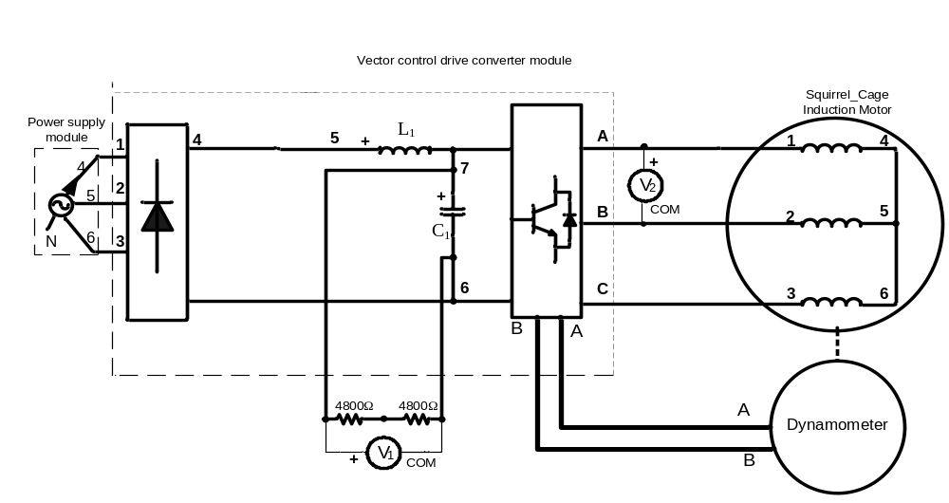
Figure.6: Connection diagram for the ac drive of a squirrel-cage induction motor operating in close loop
- Turn on the Power Supply by setting its main power switch to the marked I (on) position and set voltage control knob at 100%.
- Using the Drive Wizard application, download file CLOSE.PARMS to run the motor at 5Hz as the reference speed.

- This file will run the motor at 20 Hz as the reference speed.

Take note
Q3: Vary the input frequency of the motor by varying the frequency reference of the Vector-control Drive Converter. Using the computer, set the frequency reference to the values such as 5, 10, 20, 30, 40, 50, 60 Hz. (Don’t speed up the motor suddenly.) For each frequency, record the data of the motor input voltage V₂ and steady state speed. In your report, plot the graph of the input voltage of motor-the reference frequency and note the difference with the same of the previous run.

- When all data has been recorded depress the key.

Take note:
- As you will be working with high voltage, DO NOT come to the lab in slippers.
- Please print out all the waveforms stated in the experiment.
- Please tidy all the wires after finishing the experiments.

Please answer the following questions and attach the relevant waveforms in the report

Simulations:

Simulation 1: Introduction to PWM Inverter

1-A. 500 Hz carrier frequency (R load)
- Attach the PWMplot.m wave forms
- Attach voltage V_{ao} and line voltage V_{ab} waveforms
- Attach the source current ‘I_{a}’ FFT analysis waveform, provide the THD obtained
- Comment your observations

1-B. 2 kHz carrier frequency (R load)
a. Attach the PWMplot.m wave forms
b. Attach voltage V_{ao} and line voltage V_{ab} waveforms
c. Attach the source current ‘I_{a}’ FFT analysis waveform, provide the THD obtained
d. Comment your observations

1-C. 2 kHz carrier waveform (R-L load)
a. Attach voltage V_{ao} and line voltage V_{ab} waveforms
b. Attach the source current ‘I_{a}’ FFT analysis waveform, provide the THD obtained
c. Comment your observations

1-D. 2kHz carrier waveform, amplitude of 0.5, 100 Hz frequency of reference waveform (R-L load)
a. Attach the PWMplot.m wave forms
b. Attach voltage V_{ao} and line voltage V_{ab} waveforms
c. Attach the source current ‘I_{a}’ FFT analysis waveform and provide the THD obtained
d. Comment your observations

Simulation 2: v/f control

2-A. v/f control
  - Attach the waveforms from vfplot.m for one speed condition.
  - Record the values of motor voltage and frequency of motor for different speed references and plot V - f curve using the recorded data and comment on how v/f control works.

2-B. Effect of change of speed with ‘no load torque’
- Attach the waveforms from wTplot.m, identify the forward motoring and braking regions from torque speed characteristics and comment on your observations.

2-C. Effect of change of load torque with ‘constant speed’
- Attach the waveforms from wTplot.m, identify the forward motoring and braking regions from torque speed characteristics and comment on your observations.

Experiments:

Experiment 1: Introduction to DC-to-AC conversion using pulse width modulation (PWM) inverter

1-A. Torque vs Speed Graph of the Induction Motor
- Attach the printed waveform of torque and speed from oscilloscope
- Answer Q1 and comment on your observation

Experiment 2: Introduction to V/f Control of Squirrel-Cage Induction Motor

2-A. Open Loop V/f Control
  - Answer Q2 and comment on your observation
2-B. Closed Loop V/f Control
- Answer Q3 and comment on your observation

